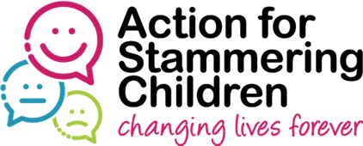
ASC – Stambition Mentoring Project
Mentee Statement of Interest Form
About you:
Surname:
First name:
Email address:
Phone number:
Home address:
Postcode:
Name on Zoom:
Gender:
Age group: | 18-21
 | 22-25

Emergency contact details:
Name of contact:
Relationship to you:
Contact telephone number:

Why do you think you would benefit from mentoring support? What do you hope to achieve from it?

What guidance are you hoping to receive from a mentor? Are there particular areas in which you would like support? Any particular skills, knowledge or experience you would like your mentor to have?

Qualifications and experience:
Please tell us about any qualifications, hobbies/interests and work or other experience you have (or would like to have) that may be helpful in matching you with an appropriate mentor

Commitments and further information:
As a mentee, you will need to commit to:
- Meeting a minimum of 6 times over a 7-month period (6 hours minimum in total)
- Attending the initial induction training
- Attending a session to provide feedback on the project and at the end of the 7-month period
- Respecting your mentor’s confidentiality in line with mentoring best practice

In light of Covid-19, it is anticipated that all meetings etc. will be held virtually via Zoom or a similar platform.

Please provide the following information for health and safety reasons. The information disclosed will enable us to assess how best we support mentees and mentors and will not necessarily prevent anyone from being accepted. Please note that we will run DBS checks on all participants.
Do you have any criminal conviction? | Yes | No
If yes, please provide details of conviction:

Are you currently on probation? | Yes | No

Please provide the name, position, address and e-mail contact details of someone who can give you a reference
Reference details:

Declaration:
I consent to the information contained in this document being shared with the Action for Stammering Children Mentoring Project so that I can be matched with a suitable mentor
Name (printed):
Signature:
Date:

Thank you for completing this form and for your interest in the Stambition Pilot Mentoring Programme.

Please return this form to:
Stephanie Nutman: Stephanie.Nutman@stammeringchildren.org

